Report
Co2 – Assessment 2 (CO2_AT2)
Q22. Closest Pair of Bus Stops Using Brute Force Algorithm
Question
A transportation system calculates distances between bus stops to identify the closest stops for route optimization. The number of stops increases daily.
a) Explain how the brute-force closest pair works here.
b) Derive its time complexity.
c) Discuss scalability issues.

1. Aim
To implement the Brute Force Closest Pair algorithm for finding the two nearest bus stops in a transportation system and analyze its efficiency.

2. Problem Statement
A transportation system stores the coordinates of bus stops. To optimize routes, it must identify the pair of bus stops with the minimum distance between them. The Brute Force algorithm checks every possible pair of bus stops and computes the Euclidean distance to determine the closest pair.

3. Objectives
- To understand the Brute Force Closest Pair algorithm.
- To calculate the minimum distance between bus stops.
- To analyze the algorithm's time complexity.
- To study its scalability as the number of bus stops increases.

4. Algorithm
- Store the coordinates of all bus stops.
- Initialize the minimum distance as infinity.
- Compare every pair of bus stops.
- Calculate the Euclidean distance between each pair.
- If the calculated distance is smaller than the current minimum distance, update the minimum distance and store the corresponding pair.
- Continue until all pairs are checked.
- Display the closest pair of bus stops and the minimum distance.

5. Source Code
import math

points = [(1,2), (4,6), (5,5), (8,9), (2,3)]

min_dist = float('inf')
closest = ()

for i in range(len(points)):
for j in range(i+1, len(points)):
d = math.sqrt((points[i][0]-points[j][0])**2 +
(points[i][1]-points[j][1])**2)

if d < min_dist:
min_dist = d
closest = (points[i], points[j])

print("Closest Bus Stops:", closest)
print("Minimum Distance:", round(min_dist,2))

6. Output
Closest Bus Stops: ((1, 2), (2, 3))
Minimum Distance: 1.41
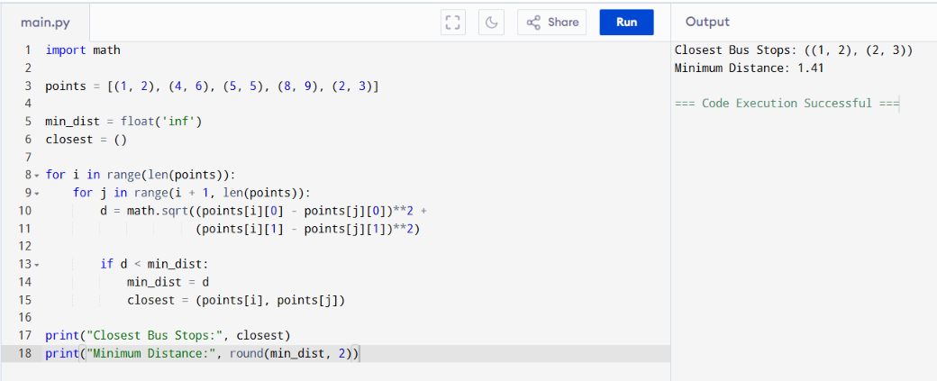

7. Analysis
The Brute Force Closest Pair algorithm compares every possible pair of bus stops. For each pair, it calculates the Euclidean distance and updates the minimum distance whenever a smaller value is found. Since every pair is checked, the algorithm always returns the correct closest pair.
For the given data:
Bus Stop 1 | Bus Stop 2 | Distance
(1,2) | (4,6) | 5.00
(1,2) | (5,5) | 5.00
(1,2) | (8,9) | 9.90
(1,2) | (2,3) | 1.41
(4,6) | (5,5) | 1.41
(4,6) | (8,9) | 5.00
(4,6) | (2,3) | 3.61
(5,5) | (8,9) | 5.00
(5,5) | (2,3) | 3.61
(8,9) | (2,3) | 8.49
The closest pair is (1,2) and (2,3) with a minimum distance of 1.41 units.

8. Time Complexity
For n bus stops, every possible pair is compared.
Number of comparisons:
$$\frac{n\left(n-1\right)}{2}$$
Therefore,
Time Complexity: O(n²)
Space Complexity: O(1)

9. Scalability Issues
The Brute Force algorithm performs well for a small number of bus stops. However, as the number of stops increases, the number of comparisons grows rapidly. This increases execution time and reduces efficiency. For large transportation systems with thousands of bus stops, the algorithm becomes impractical. More efficient algorithms, such as the Divide and Conquer Closest Pair algorithm with O(n log n) time complexity, are preferred.

10. Conclusion
The Brute Force Closest Pair algorithm successfully identifies the nearest pair of bus stops by checking every possible pair. It is simple to understand and guarantees the correct result. However, its O(n²) time complexity makes it unsuitable for large datasets. Although effective for small transportation networks, more efficient algorithms should be used for large-scale route optimization.

